**CS 3132 Cloud Computing Lab Report (2024-25) (Jul-Dec)**

**Student Name: Aryan Vats**

**Registration ID:BT22GCS208**

**Section: C3**

**Email ID: Aryan.vats22@st.niituniversity.in**

**Assignment Date: 16-09-2024**

**Completion Date** *(when you completed the lab assignment)***:** *17-09-2024*

**1. Lab Assignment #4:** Exploring and Comparing Cloud Storage Services

**Objective**: The objective of this assignment is to install various cloud storage services and exploring at least five different platforms, including **Syncany**, **ownCloud**, **Mega**, and two additional services of the student's choice (*excluding Google Drive, OneDrive, Dropbox, and iCloud*). Students are expected to evaluate the **usability**, **features**, and **performance of each cloud service**, and provide a detailed comparison based on factors such as

1. **ease of use,**
2. **security,**
3. **storage capacity,**
4. **synchronization capabilities, and**
5. **platform compatibility**.

This exercise will help to gain practical insights into cloud storage solutions and their differences in real-world applications.

**2. Hardware Requirement:**

* **Computer**
* **Any modern processor (dual-core or better) will be sufficient for accessing cloud storage.**
* **Minimum: 2 GB of RAM.**

**3. Software Requirement:** Syncany, Owncloud, Mega, Pcloud, IDrive

**4. Lab Tasks:**

* **Syncany**
* Ease of Use: Syncany is an open-source file synchronization tool with a strong focus on privacy. While it simplifies secure file syncing, its interface can be more complex compared to mainstream solutions, requiring a more advanced understanding to set up and use. Users familiar with command-line interfaces will find it more suitable, as its graphical interface isn't as intuitive as other popular cloud services.
* Security Features: Syncany offers comprehensive security with end-to-end encryption, ensuring that files are encrypted before they leave your device. However, the overall security depends on the external storage provider you connect it to, such as Google Drive, FTP servers, or WebDAV. The safety of your data is influenced by the security features of these third-party storage systems.
* Storage Capacity: Unlike other cloud services, Syncany doesn’t come with built-in storage. Users need to integrate it with an external storage provider, meaning storage limits depend on the third-party service you choose to use (e.g., Google Drive's storage limits).
* Additional Insights: Syncany's decentralized nature allows you to use any storage backend, making it highly flexible. This is particularly appealing to users who want to manage their own storage locations while keeping full control over their data's encryption and privacy. It is designed for advanced users who value security and flexibility over ease of use and who don’t mind managing their own cloud infrastructure.

* **OwnCloud**
* **Ease of Use**: ownCloud provides a user-friendly experience through its online and desktop applications, making it relatively easy to set up for users. However, for those looking to host their own server, a moderate level of technical expertise is required, which might pose a challenge for beginners or non-technical users.
* **Security**: ownCloud is equipped with robust security features such as end-to-end encryption and two-factor authentication. It offers complete control over data to administrators, making it an excellent choice for individuals and organizations that prioritize privacy and security. The self-hosted nature of ownCloud ensures that users can manage who accesses their data.
* **Storage Capacity**: ownCloud does not set any default limits on storage. The storage capacity is determined by the physical or cloud resources of the server on which it is hosted. This allows for scalability, meaning it can handle vast amounts of data, depending on the underlying infrastructure.
* **Synchronization Capabilities**: ownCloud excels in file synchronization, offering reliable and fast syncing across devices. Its built-in version control system is a standout feature, allowing users to recover or roll back to previous file versions effortlessly, while real-time sync keeps data up to date across all platforms.
* **Platform Compatibility**: With support for major platforms including Windows, macOS, Linux, Android, and iOS, ownCloud is highly versatile. It also features a web-based interface, making it accessible from any modern browser, which enhances convenience and accessibility for users across different devices.
* **Additional Insights**: ownCloud is particularly appealing for organizations or tech-savvy individuals who want to host and control their own cloud infrastructure. Its flexibility, combined with strong privacy measures, makes it a popular choice for businesses looking to maintain autonomy over their data while ensuring high-level security.

* Mega
* **Ease of Use**: Mega is designed with simplicity in mind, offering an intuitive user experience across its web and desktop applications. Its easy setup process makes it suitable for both beginners and advanced users, providing a seamless interface that simplifies cloud storage and file sharing.
* **Security**: Mega is known for its strong focus on security, providing end-to-end encryption where only the user holds the decryption key. This means even Mega cannot access your files. Additionally, it supports two-factor authentication, making it a great option for users who are highly concerned about privacy.
* **Storage Capacity**: Mega offers a generous amount of free storage (20 GB), with options to expand through premium plans. Users can choose plans that suit their needs, scaling up to multiple terabytes of storage. This makes it suitable for both personal and professional use with significant data requirements.
* **Synchronization Capabilities**: Mega offers reliable file synchronization across devices with its "MegaSync" feature. Files are synced automatically in real-time, ensuring that users always have the most up-to-date versions. It also supports file versioning, allowing users to recover previous versions of their files.
* **Platform Compatibility**: Mega is available across a wide range of platforms, including Windows, macOS, Linux, Android, and iOS. It also provides a browser-based interface for easy access from any device, further enhancing its accessibility.
* **Additional Insights**: Mega’s unique approach to user-controlled encryption makes it one of the most privacy-focused cloud storage services. However, since only users possess the decryption key, losing it means permanent loss of access to files. This feature, while great for privacy, requires careful handling by users to avoid accidental data loss. Mega is ideal for privacy-conscious individuals and businesses that need secure, scalable storage.

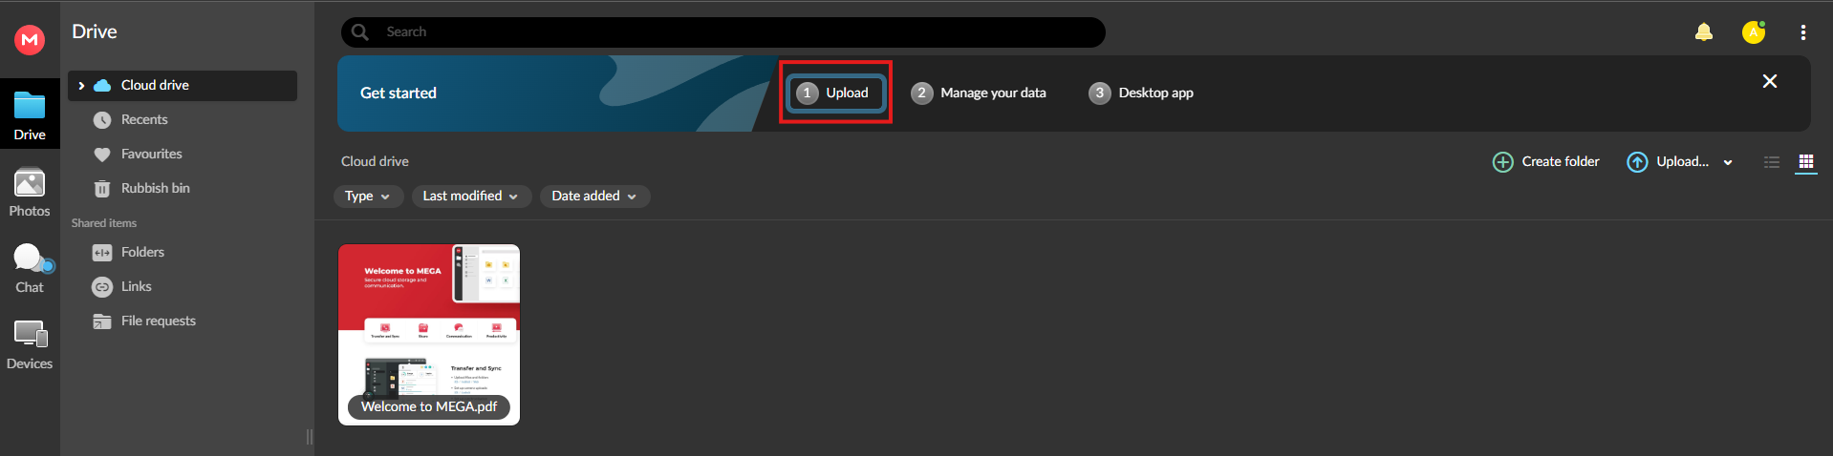

* Pcloud
* **Ease of Use**: pCloud offers a smooth and easy-to-navigate user experience, with straightforward setup and use across its web, desktop, and mobile apps. It requires minimal technical expertise, making it accessible to users of all skill levels, from beginners to advanced users.
* **Security**: pCloud provides strong security measures, including optional client-side encryption through its pCloud Crypto add-on, which ensures that only the user can access encrypted files. The service also includes TLS/SSL encryption for data transfer. While encryption is an optional feature, users looking for an extra layer of security can easily enable it.
* **Storage Capacity**: pCloud offers generous storage options, starting with 10 GB of free storage, and users can expand their storage with affordable lifetime or subscription plans. It is known for its lifetime plan, allowing users to pay once for permanent cloud storage. The storage capacity can scale to meet personal or business needs, with plans offering up to 2 TB or more.
* **Synchronization Capabilities**: pCloud provides reliable and real-time synchronization between devices, ensuring that files are kept up-to-date. Its selective sync feature allows users to choose which folders to sync, optimizing storage space on local devices. The service also includes file versioning, enabling users to access previous versions of files for easy recovery.
* **Platform Compatibility**: pCloud supports a wide variety of platforms, including Windows, macOS, Linux, Android, and iOS, ensuring accessibility across multiple devices. Additionally, it offers a web-based interface, making it easy to manage files from any browser without needing to install software.
* **Additional Insights**: pCloud is one of the few cloud storage services that offers a lifetime plan, making it an attractive option for users who want a long-term investment in cloud storage without recurring fees. Its client-side encryption (pCloud Crypto) provides an extra layer of privacy for users who want full control over their data security. With its combination of affordability, ease of use, and robust security, pCloud is a strong contender for both personal and business cloud storage solutions.

* IDrive
* **Ease of Use**: IDrive offers a straightforward interface that is user-friendly and easy to navigate, catering to both beginners and experienced users. Its desktop and mobile apps make it simple to set up and manage backups, with clear options for file syncing and sharing. Though there are many features, they are well-organized, making the service accessible without overwhelming new users.
* **Security**: IDrive ensures strong security with AES 256-bit encryption for both data transfer and storage. Users also have the option of choosing private encryption keys, meaning only they have access to the encrypted files. This high level of security makes it a solid choice for users and businesses that handle sensitive data.
* **Storage Capacity**: IDrive offers a range of plans, starting with a free plan that provides 10 GB of storage. Paid plans come with scalable storage options ranging from 5 TB to 50 TB, making it ideal for both personal users with moderate needs and businesses that require large-scale data backups.
* **Synchronization Capabilities**: IDrive allows real-time file synchronization across multiple devices, including PCs, Macs, and mobile devices. It ensures that changes made on one device are quickly reflected across all connected devices. In addition, it provides file versioning, allowing users to restore previous versions of their files when needed.
* **Platform Compatibility**: IDrive supports a wide array of platforms, including Windows, macOS, Linux, Android, and iOS, providing flexibility and ease of use across different devices. It also offers a browser-based interface for users who prefer to manage their backups and files without installing additional software.
* **Additional Insights**: IDrive is particularly well-suited for users who need both cloud storage and backup solutions in one platform. It excels at data backups, offering hybrid options that combine local and cloud-based storage. The service is also known for its excellent pricing plans, which provide great value for both individuals and businesses with extensive backup needs. Its private encryption option and ability to back up multiple devices under a single account make IDrive a strong choice for those focused on both security and efficiency.

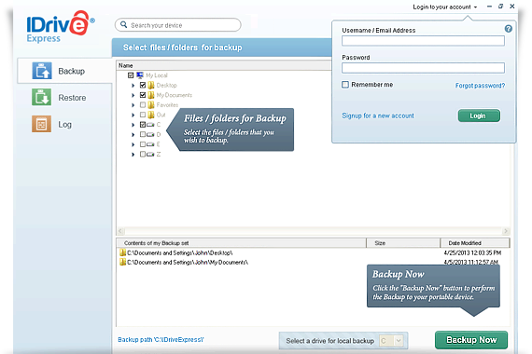

**5. Observations:**

**- Syncany: Best for advanced users who want control over storage locations and encryption but requires command-line experience.**

**- ownCloud: Ideal for privacy-conscious users or organizations with technical skills to manage a self-hosted cloud solution.**

**- Mega: Strong focus on privacy with user-controlled encryption, offering generous free storage and simple setup.**

**- pCloud: User-friendly with lifetime plans and optional client-side encryption, making it great for privacy and long-term storage.**

**- IDrive: Excellent for backups with hybrid cloud/local storage, supporting multiple devices and offering solid security options.**

**6. Results and Analysis:**

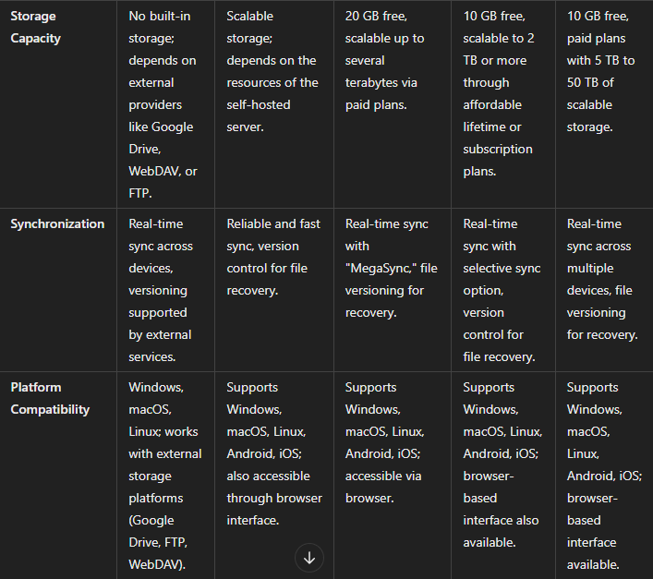

**7. Conclusion:**

In conclusion, each cloud storage service has its strengths tailored to different user needs. Syncany and ownCloud are ideal for tech-savvy users seeking control and privacy, while Mega and pCloud offer user-friendly options with strong security and flexibility. IDrive excels as a comprehensive backup solution with multi-device support and hybrid storage options. Choose based on your priority—whether it's ease of use, privacy, or extensive storage**.**

**8. References:**

* **Syncany:**
* [**Syncany Official Website**](https://www.syncany.org/)
* [**Syncany GitHub Repository**](https://github.com/syncany/syncany)
* **ownCloud:**
* [**ownCloud Official Website**](https://owncloud.com/)
* **ownCloud Documentation**
* **Mega:**
* [**Mega Official Website**](https://mega.nz/)
* **Mega Security Information**
* **pCloud:**
* [**pCloud Official Website**](https://www.pcloud.com/)
* **pCloud Security and Privacy**
* **IDrive:**
* [**IDrive Official Website**](https://www.idrive.com/)
* **IDrive Security Features**

**9. Appendix:**